MEASURING THE PULSE OF PROSPERITY:

AN INDEX OF ECONOMIC FREEDOM ANALYSIS

TEAM MEMBERS  
 1.Sneha Alisetty

2.Tharugu Sreelakshmi

3.N Sreelatha

4. Nasina Sriram

1. INTRODUCTION

1.1 Overview:

* Economic freedom is the fundamental right of every human to control his or her own labor and property.

* In an economically free society, individuals are free to work,produce,consume and invest in any way they Please.

* An index of economic freedom analysis compares the jurisdiction against each other for various aspects such as trade freedom,judicial effectiveness and tax Burden.

Purpose:

* This helps in rising income and consumption for the Bulk of the population.  
* It measures the `economic freedom’ or the ability of Individuals to make their own economic decision in a Country by analysing policies and institutions of these Countries.

* Economic freedom means that people can engage in trade with any person of their choosing.If the Government taxes or otherwise prevents people from

buying or selling with people in other countries, it Reduces their freedom.

**2. PRROBLEM DEFINITION AND DESIGN THINKING  
 2.1 Empathy Map:**

Empathy Map Canvas:

An Empathy Map is a simple and powerful tool that helps us understand our users better. It

shows what users say, think, do, and feel, giving us a complete picture of their experiences,

challenges, and goals.

This tool is especially helpful during the "empathize" stage of designing a product or solving

a problem. It helps teams stay focused on real human emotions, pain points, and

motivations—important factors when creating meaningful, user- centered solutions.

Applying the Empathy Map: Measuring the Pulse of Prosperity Project

In this project, we use the empathy map to better understand the people working with

economic freedom data, such as:

• Policy analysts

• Economists

• Decision-makers

By exploring their experiences, we uncover key insights:

• Pain Points: They often struggle to interpret complex, multi-layered data.

• Needs: They want simple, interactive dashboards that clearly show important

patterns and trends.

These insights guide us in designing effective Tableau dashboards that make data easier to

understand and help users make smarter, more informed decisions  
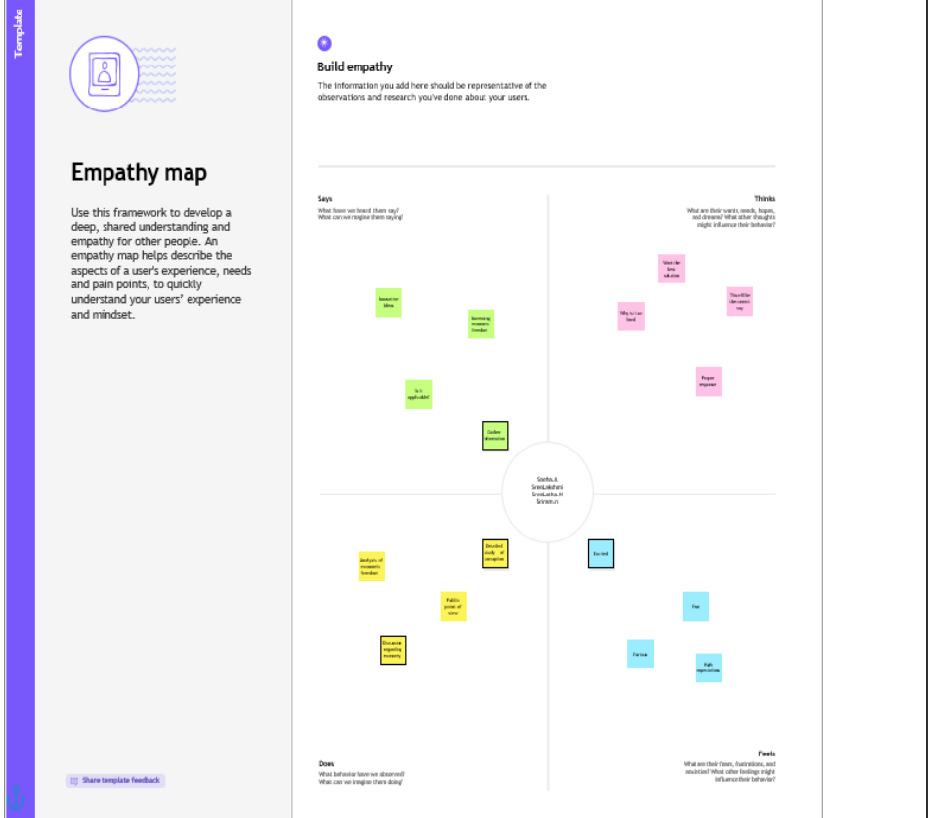

2.2 Ideation & Brainstorming Map:  
Brainstorming sessions offer a collaborative space where team members contribute freely

, explore creative ideas, and develop innovative solutions without limitations.

Emphasizing idea quantity over perfection, this process encourages open participation,

constructive input, and imaginative thinking.

Use this template to guide your brainstorming sessions, especially in collaborative

analytics projects—even when team members are working remotely.

Project Title:

Measuring the Pulse of Prosperity: An Index of Economic Freedom Analysis

project Overview:

In this project, our team of five data analysts set out to explore and visualize the state of

economic freedom across countries and over time. Leveraging Tableau dashboards, we

aimed to uncover how different components of economic freedom correlate with

national prosperity and governance.

Primary Research Questions:

1. How does economic freedom vary across countries and years?

2. Which trends and indicators in the Economic Freedom Index can guide policymakers

toward improved economic outcomes?

Task Allocation:

Roles and responsibilities were distributed based on each team member’s strengths: • Data Cleaning & Transformation • Exploratory Data Analysis • Visualization Design in Tableau • Insights Interpretation & Reporting • Presentation & Documentation.

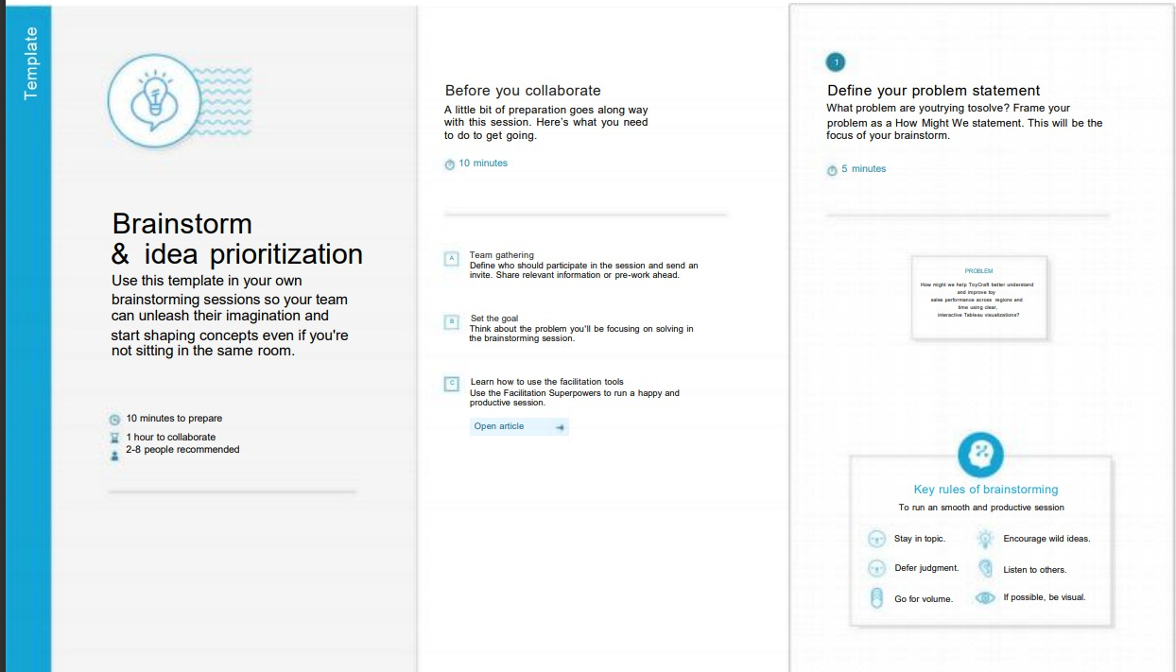

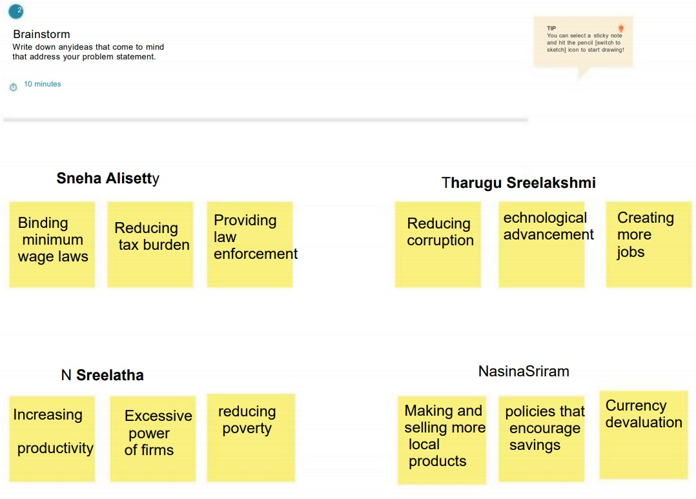  
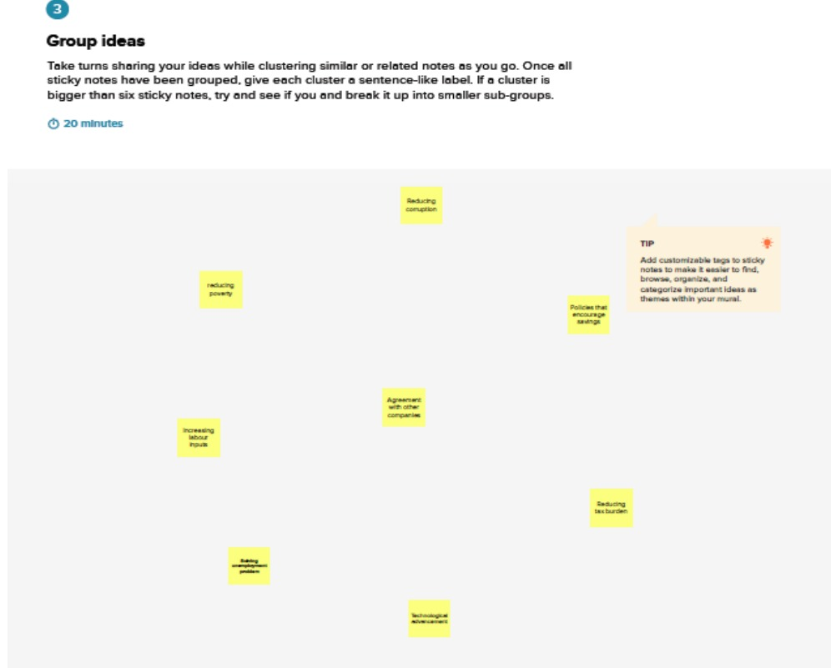  
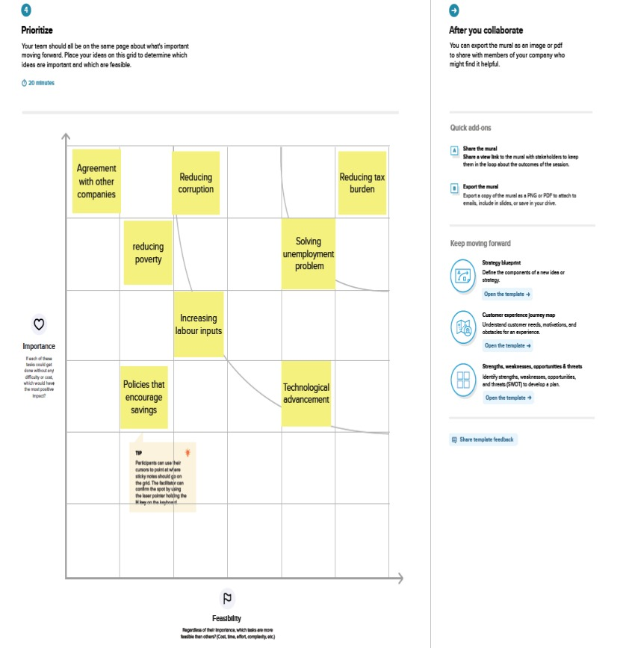

3. RESULT:(Dashboard)

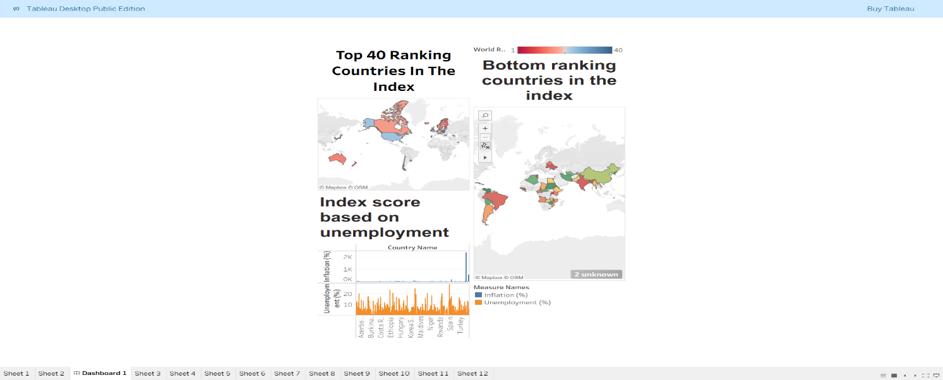

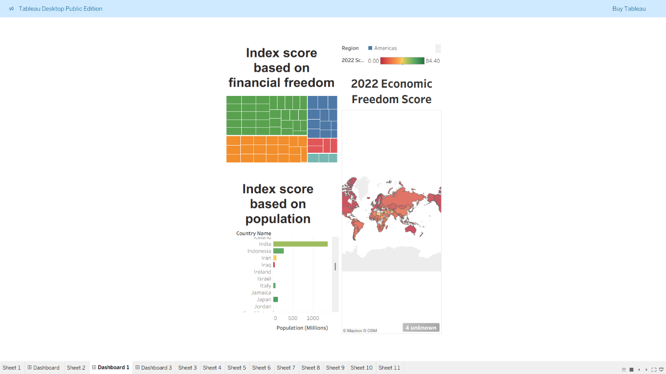

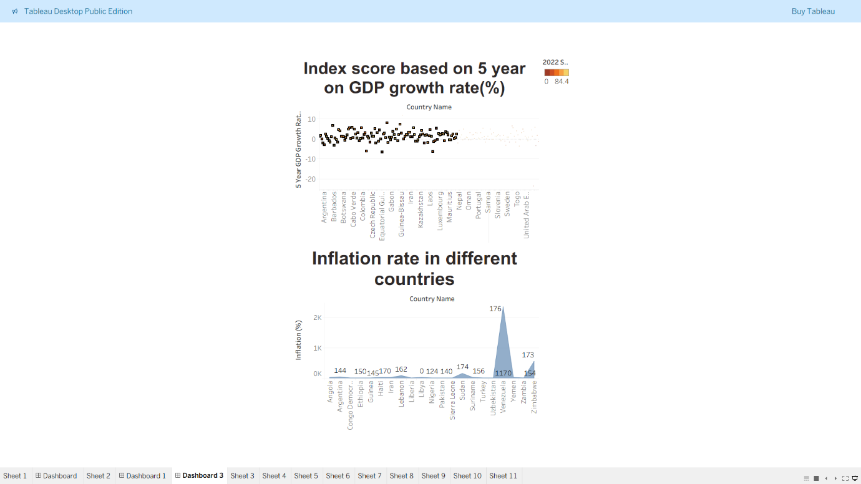

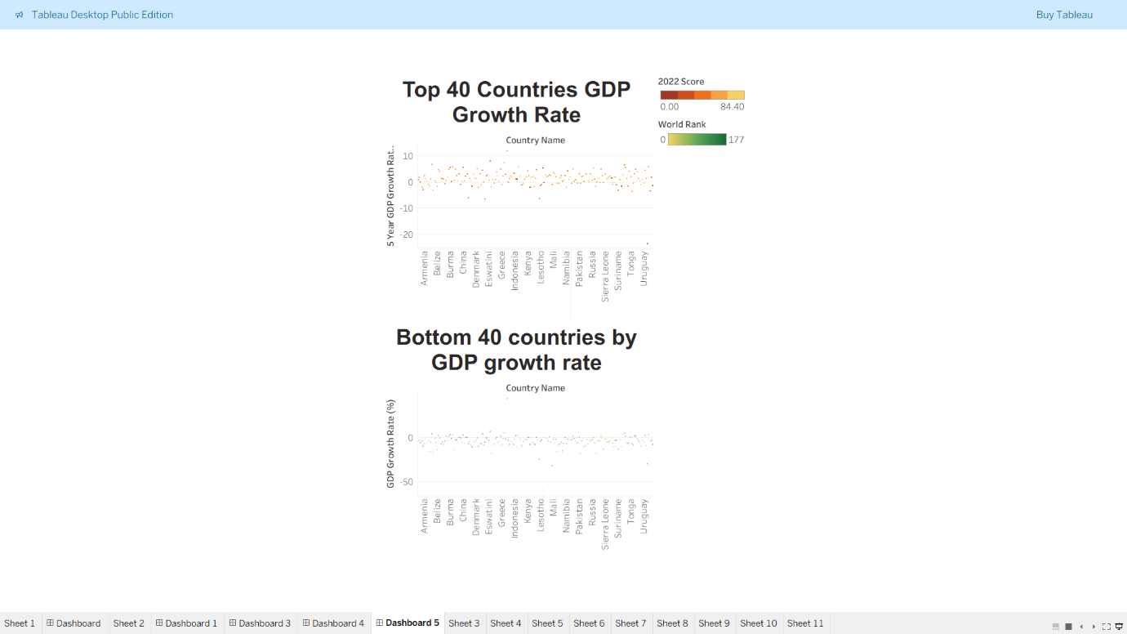

STORY:  
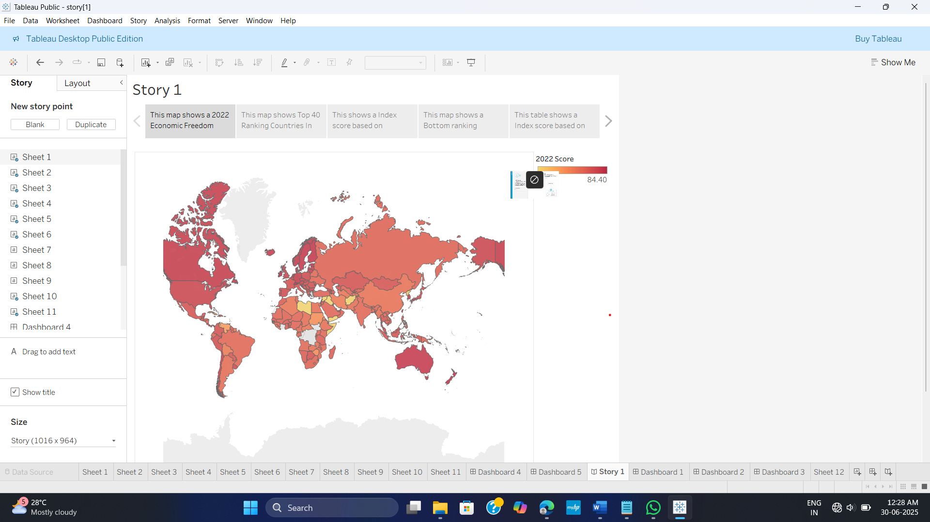

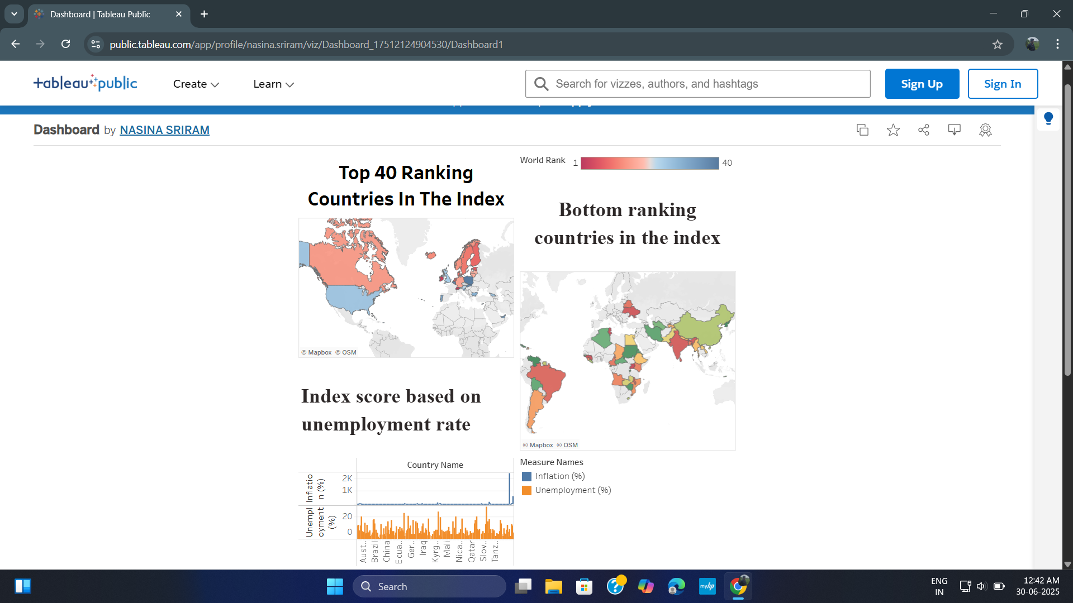

4 ADVANTAGES & DISADVANTAGES

ADVANTAGES

* It is the most conducive to widespread prosperity.

* Nations with greater economic freedom have stronger economies,with

Higher gross domestic product per person.

* Citizens in countries that are economically free enjoy twice as much

Formal education on average as those in economically repressed

Nations.

* Free trade is a key element of economic freedom.Countries that

Embrace free trade enjoy more prosperity as a result.

DISADVANTAGES

* There are of course extreme cases when economic freedom cannot

Be deemed beneficial because large costs are imposed upon third

Parties who are not or cannot be compensated.

* Creates scarcity due to an inability to plan for individual needs.

* A free market economy requires consumption to survive.

* Equality doesn`t always equate to equal opportunities.

## 5 APPLICATIONS

* Areas where the economic freedom focuses on include

Health,education,working conditions,and market conditions.

* Developing of economic freedom analysis seeks to understand and

Shape macro and micro economic policies in order to lift poor

Countries out of poverty.

6 CONCLUSION:

We came across a lot of countries economic status and their trade

Freedom and we used the data to create a graph to find economic

Score,unemployment rate,financial freedom and GDP growth rate of

Countries.

7 FUTURE SCOPE

We have expressed our thoughts and ideas in our project.By reducing the

Tax and by increasing the job vacancies we could enhance our economic

freedom